Searching Better
Being able to search online is one of the most important digital literacy skills you can possess. The most important tool in this process is the search engine; you’ve probably heard of the popular ones, including Google, Yahoo! And Bing.
How to start searching:
Option 1: The homepage.
Go to your search engine’s homepage, for example google.com, and type your search terms into the text box.
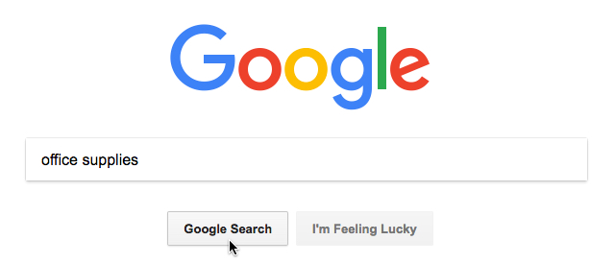

Option 2: Your browser’s address bar.
Most browsers let you search straight from the address bar.
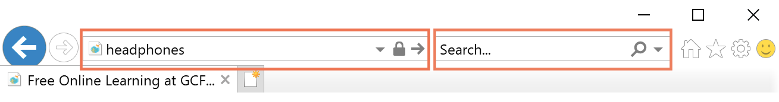
It may be a particular search engine by default, but you can change what engine you use within your browser’s settings.

Search Strategies:
- Keep it simple: Make your searches brief by focusing on keywords, then keep the number of these keywords to a minimum. This way, you're more likely to get relevant results.

- Consider suggestions: As you enter your term, search engines will suggest the most popular results involving the term so don't be afraid to select one, as they can often give you plenty of new ideas.

- Use natural language: You don't have to use complicated words or phrases to get results. Search engines can recognize the language you naturally use in your everyday life, so feel free to try whatever comes to mind.
Finding specific types of content:
Search engines can find other types of content in addition to webpages. You can filter down to images, videos, and more.
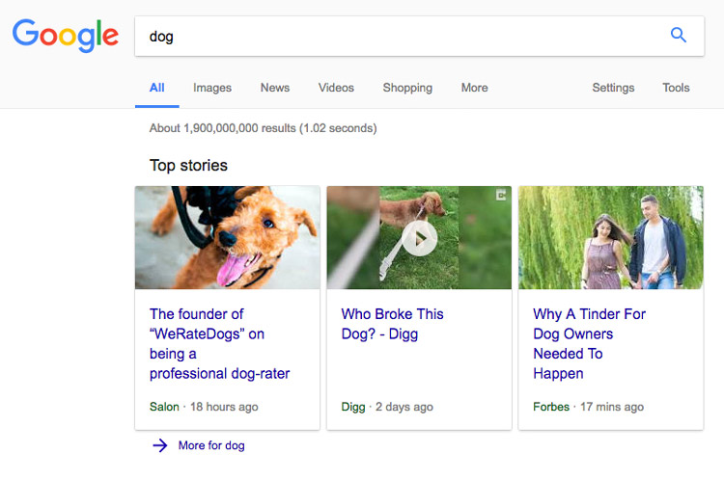
Typically, what you’re looking for will be in the first page of your results. Sometimes, you need to look a little harder. Next up is Advanced Search.
Advanced Search:
Most search engines have an advanced search option available. You can search everything from the date an article was written to the country it was written in.
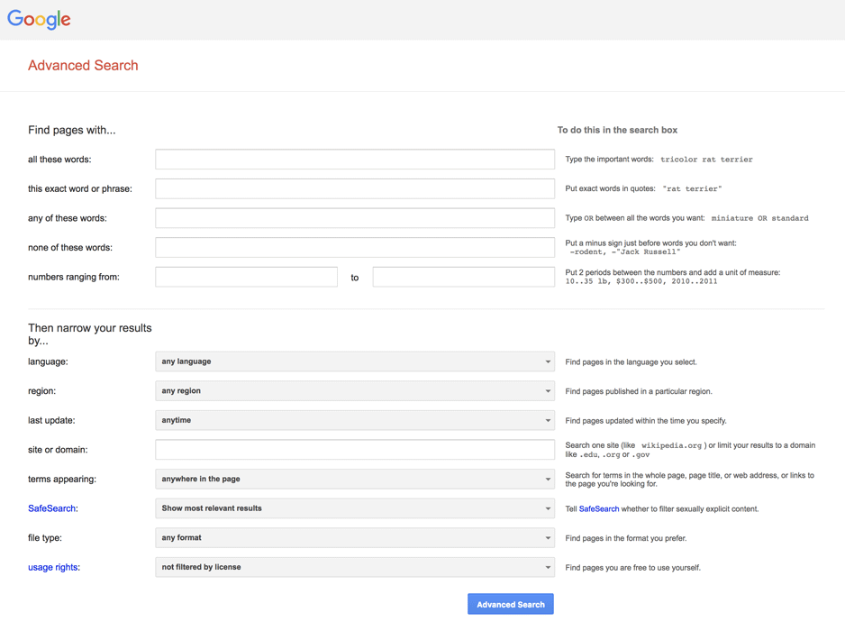

Fast Facts with Google:
Google will answer common questions and simple math questions from the search bar. Just type in your questions and the will display at the top of the page.
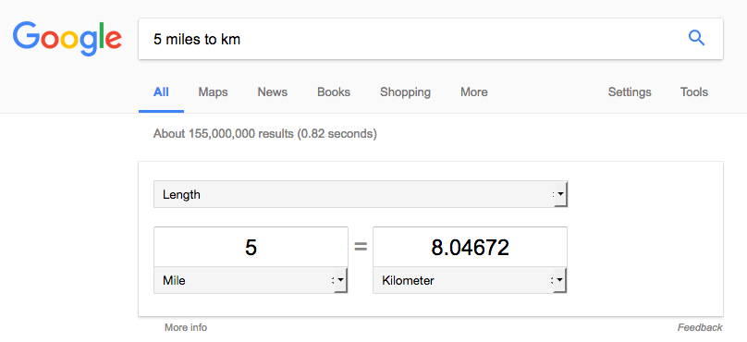

Use the Tools function:

To refine your search results, try the Tools function. Let’s say you’re searching for images of acoustic guitars, but you only want to see green guitars. After you click Tools, select Color and then the green square to filter the results. In addition to sorting by size or publication date, you can click other tabs like News and Videos to sort these results in similar ways.

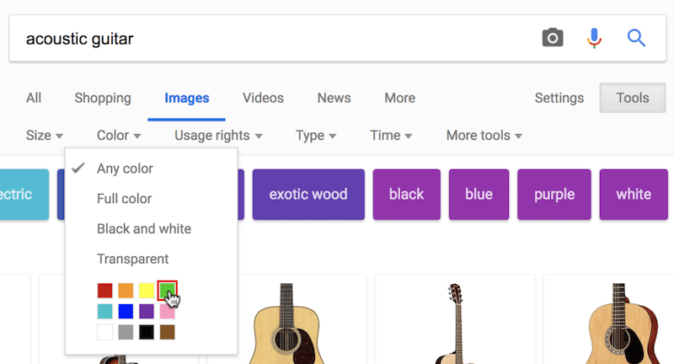
Improving your thought process:
When searching the web for information, it’s important to be able to tell what sources are legitimate. Take a look at each site carefully before deciding whether or not it’s a worthwhile source.
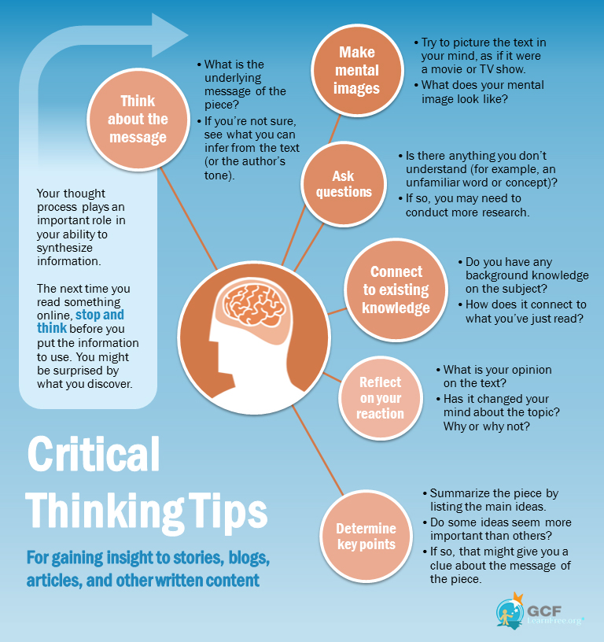

Watching out for copyrighted content:
Google is a great resource for finding images and works for personal projects. However, you need to make sure that whatever you’re using isn’t copyrighted. Luckily, Google has a feature that will filter copyrighted materials.
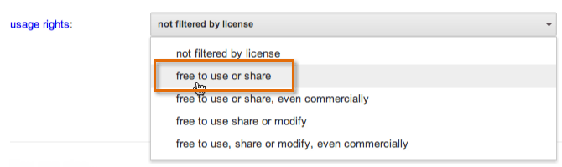
Give credit to the copyright holder.
In order for something to be fair use, you must give full credit to the person who created it. This includes the creator's name, as well as other information that will help people find the original work or source. For example, if you adapt a recipe that was originally published on a cooking website, you should include a link to the original page.
Don't make money off of the copyrighted work.
In general, it's much easier to claim fair use when you're using the copyrighted material for noncommercial purposes. While posting images of your favorite TV shows and adding funny captions and commentary might be considered fair use, selling these images on T-shirts would not.

Using Google Scholar:
Google Scholar is a fantastic tool for finding peer reviewed research. It can be reached at Scholar.Google.Com. It functions the same as Google Search, though the advanced search is more tailored towards research. After typing in what kind of research you’re looking for, you can further refine your results on the left side of the screen (left).

Advanced Search:
Google Scholar’s Advanced Search is a bit different from the standard Advanced option. You can search by anything from subject to author. You can also choose to search specifically by title or by article content.

